MAJOR PROJECT 2

IMAGE PROCESSING

By Akshat Burman

IIT Bhubaneswar

2nd year

Mechanical Engineering

CODE:

import cv2

#capturing a particular frame from webcam

key = cv2. waitKey(1)

webcam = cv2.VideoCapture(0)

while True:

check, frame = webcam.read()

cv2.imshow("Capturing", frame)

key = cv2.waitKey(1)

if key == ord('c'): #by pressing 'c' key on the keyboard it captures the frame from the webcam

cv2.imwrite(filename='saved_img.jpg', img=frame)#saving that image

webcam.release()

cv2.waitKey(1650)

cv2.destroyAllWindows()

break

#face detection

face_cascade = cv2.CascadeClassifier('haarcascade_frontalface_default.xml')#importing haarcascade

img = cv2.imread('saved_img.jpg')

gray = cv2.cvtColor(img,cv2.COLOR_BGR2GRAY)

faces = face_cascade.detectMultiScale(gray,1.1,9)

for x,y,w,h in faces:

img = cv2.rectangle(img,(x,y),(x+w,y+h),(0,255,0),4)

cv2.imshow('Face Detection',img)#face detected

cv2.waitKey(0)

cv2.destroyAllWindows()

SAVED IMAGE: (saved_img.jpg)

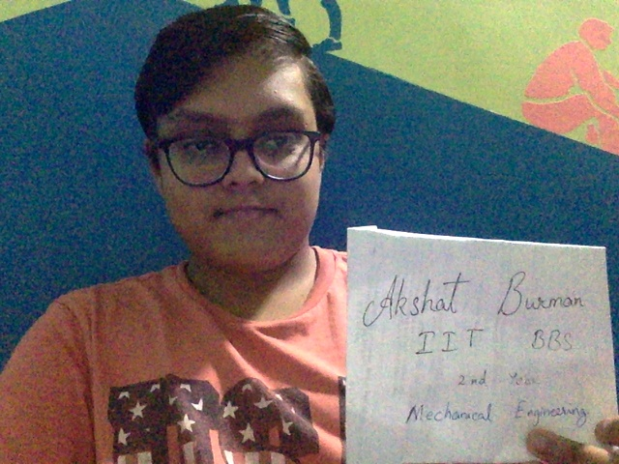

LIVE FACE DETECTION:

